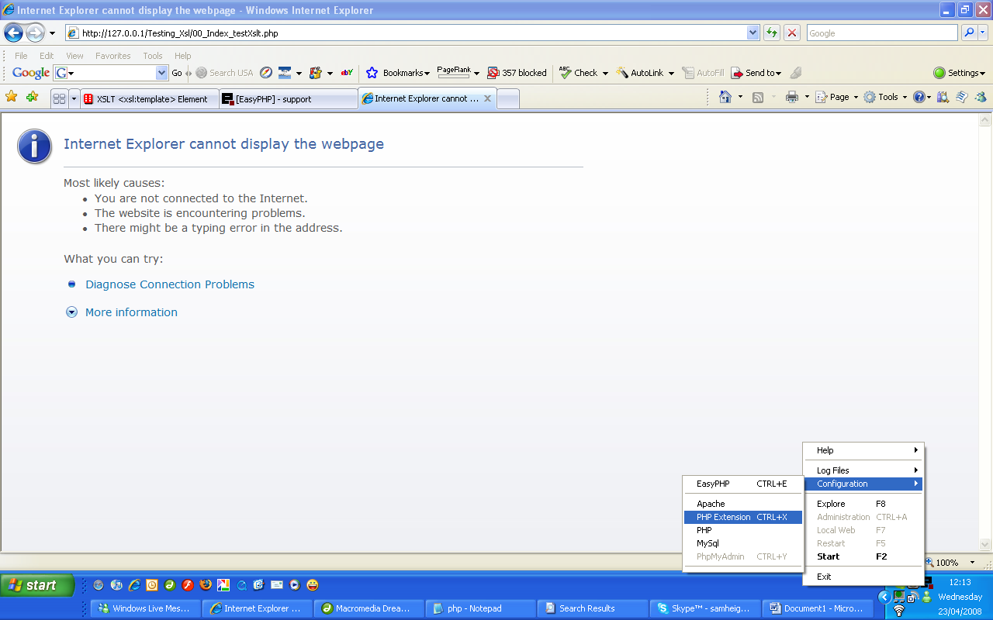

Double check xsl extension is enabled in Easy PHP.
Right click on easyphp icon in right corner panel
Choose, Configuration, PHP Extension

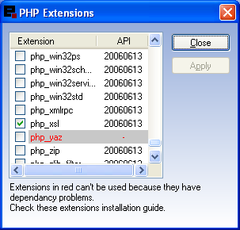

Check php_xsl and then click apply.

The extension is now installed

